## Problem (Variant B)

You are expected to create the following set of resources:

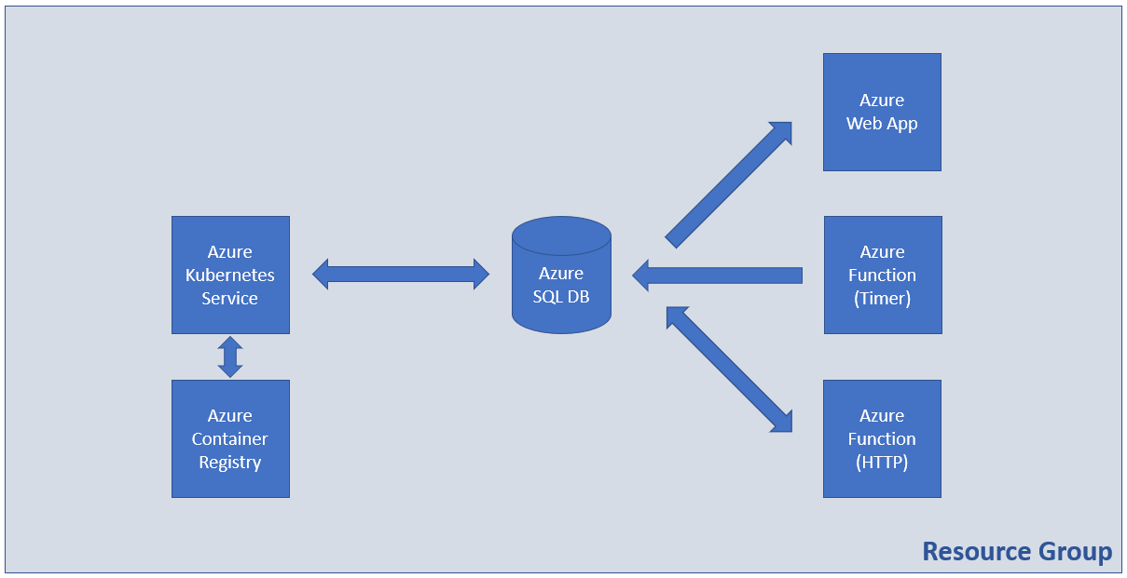

### Tasks

#### Infrastructure - 5 tasks, 13 pts

* (T101, 1 pts) Create a resource group named **RG-SolutionB**

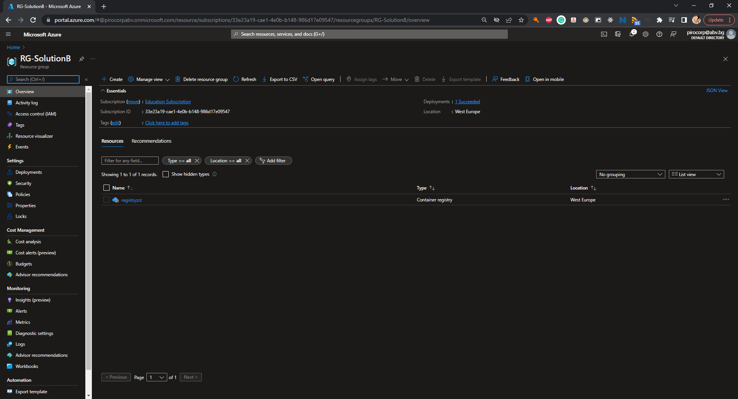

* (T102, 3 pts) Create a container registry with **Basic** SKU

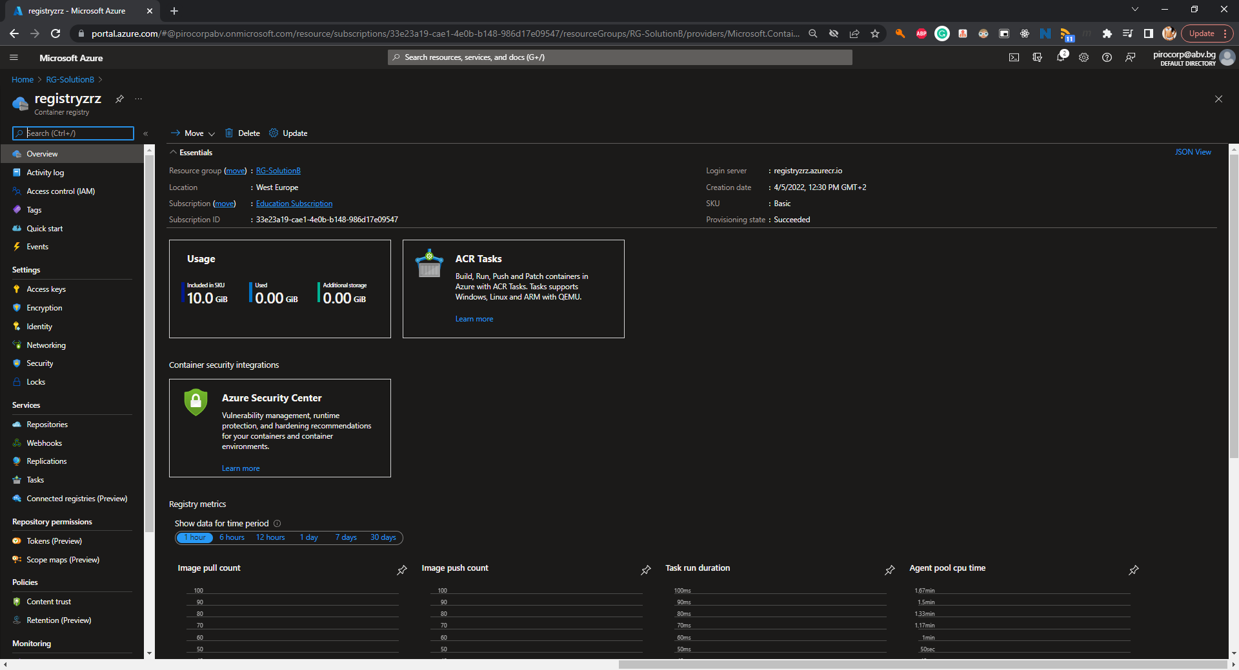

* (T103, 2 pts) Enable the Admin user

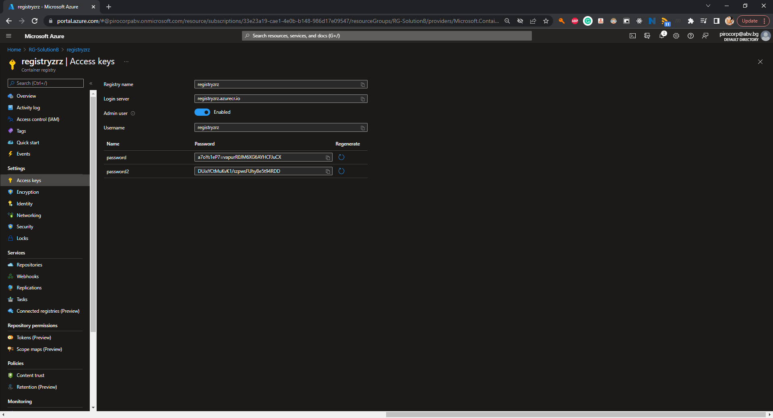

* (T104, 5 pts) Create an Azure Kubernetes Service resource with **one node** of size **B2s**

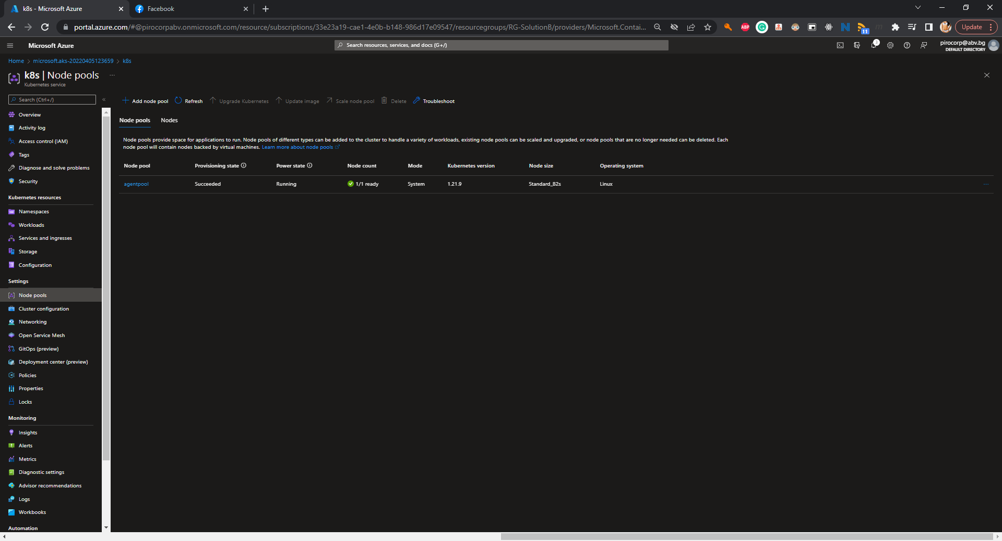

* (T105, 2 pts) **Link** the ACR to the AKS

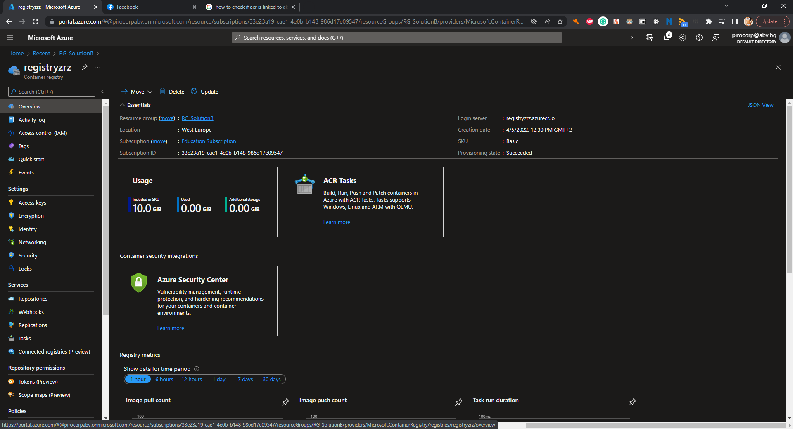

#### Containers and Images - 7 tasks, 16 pts

* (T201, 2 pts) Add the SQL connection string to the **index.php** file in the **docker/web** folder

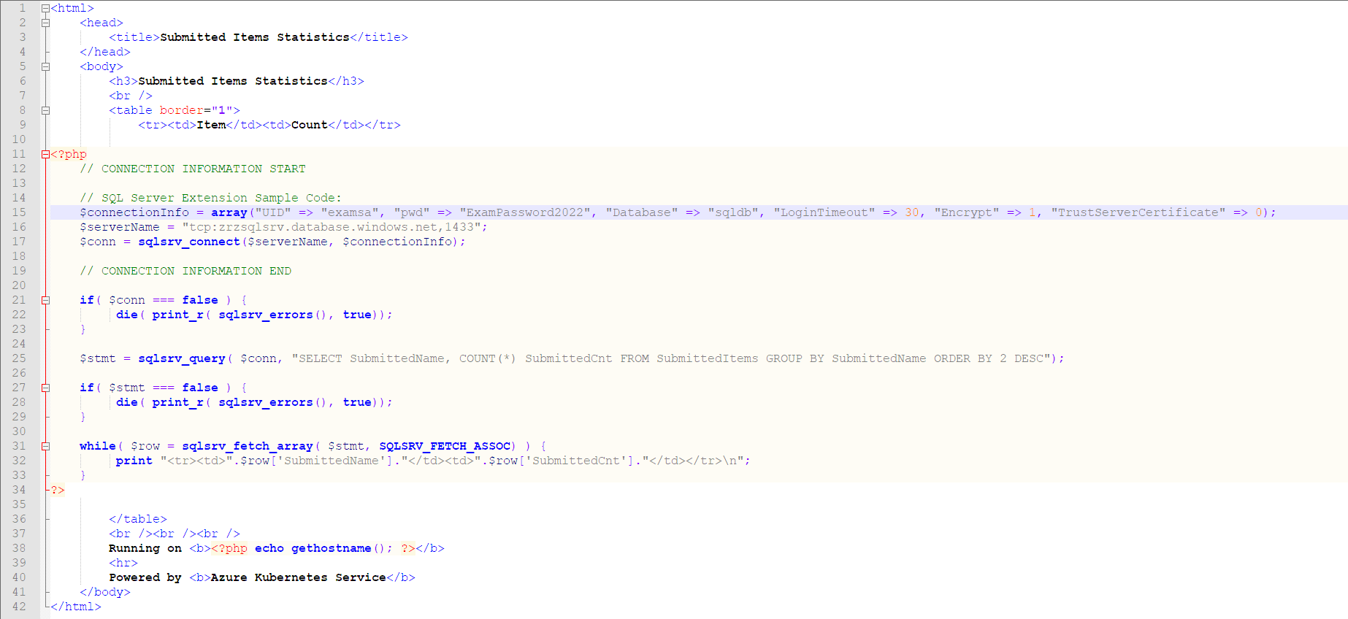

* (T202, 2 pts) Build the Docker image from the **Dockerfile** that is in the **docker** folder

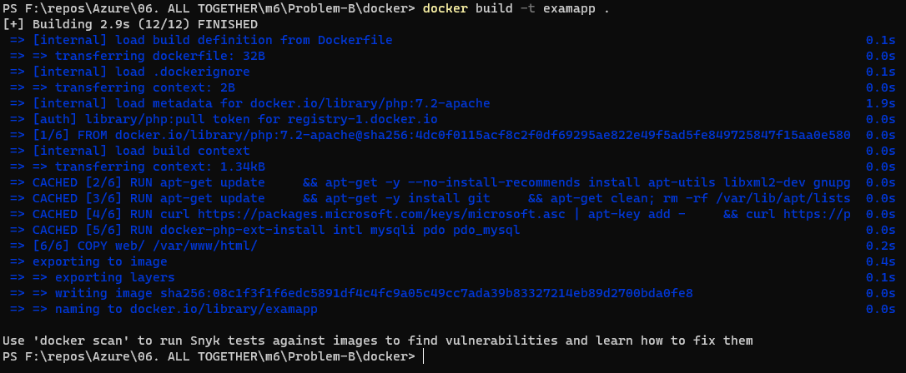

* (T203, 2 pts) Tag the Docker image for the Azure Container Registry

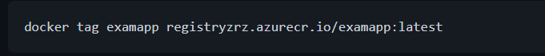

* (T204, 2 pts) Publish the Docker image to the Azure Container Registry

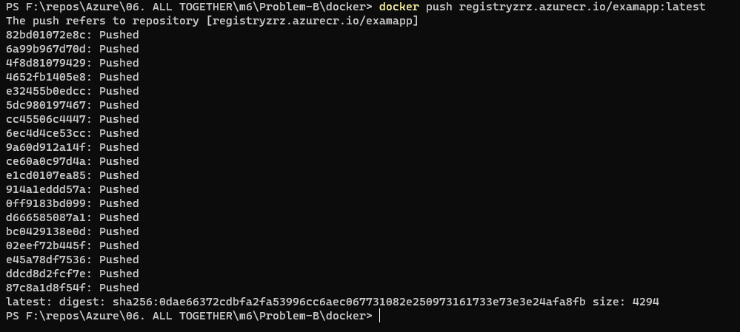

* (T205, 3 pts) Adjust the **deployment.yaml** file in the **manifests** folder to point to the published Docker image

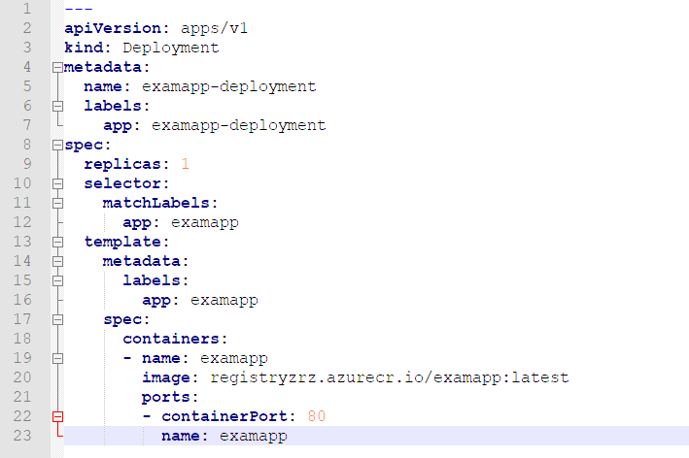

* (T206, 2 pts) Publish the manifests to the Kubernetes cluster (Azure Kubernetes Service)



* (T207, 3 pts) Make sure that the app is working and showing correct results

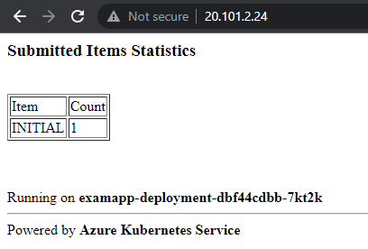

#### Databases - 3 tasks, 9 pts

* (T301, 3 pts) Create SQL Server and a database

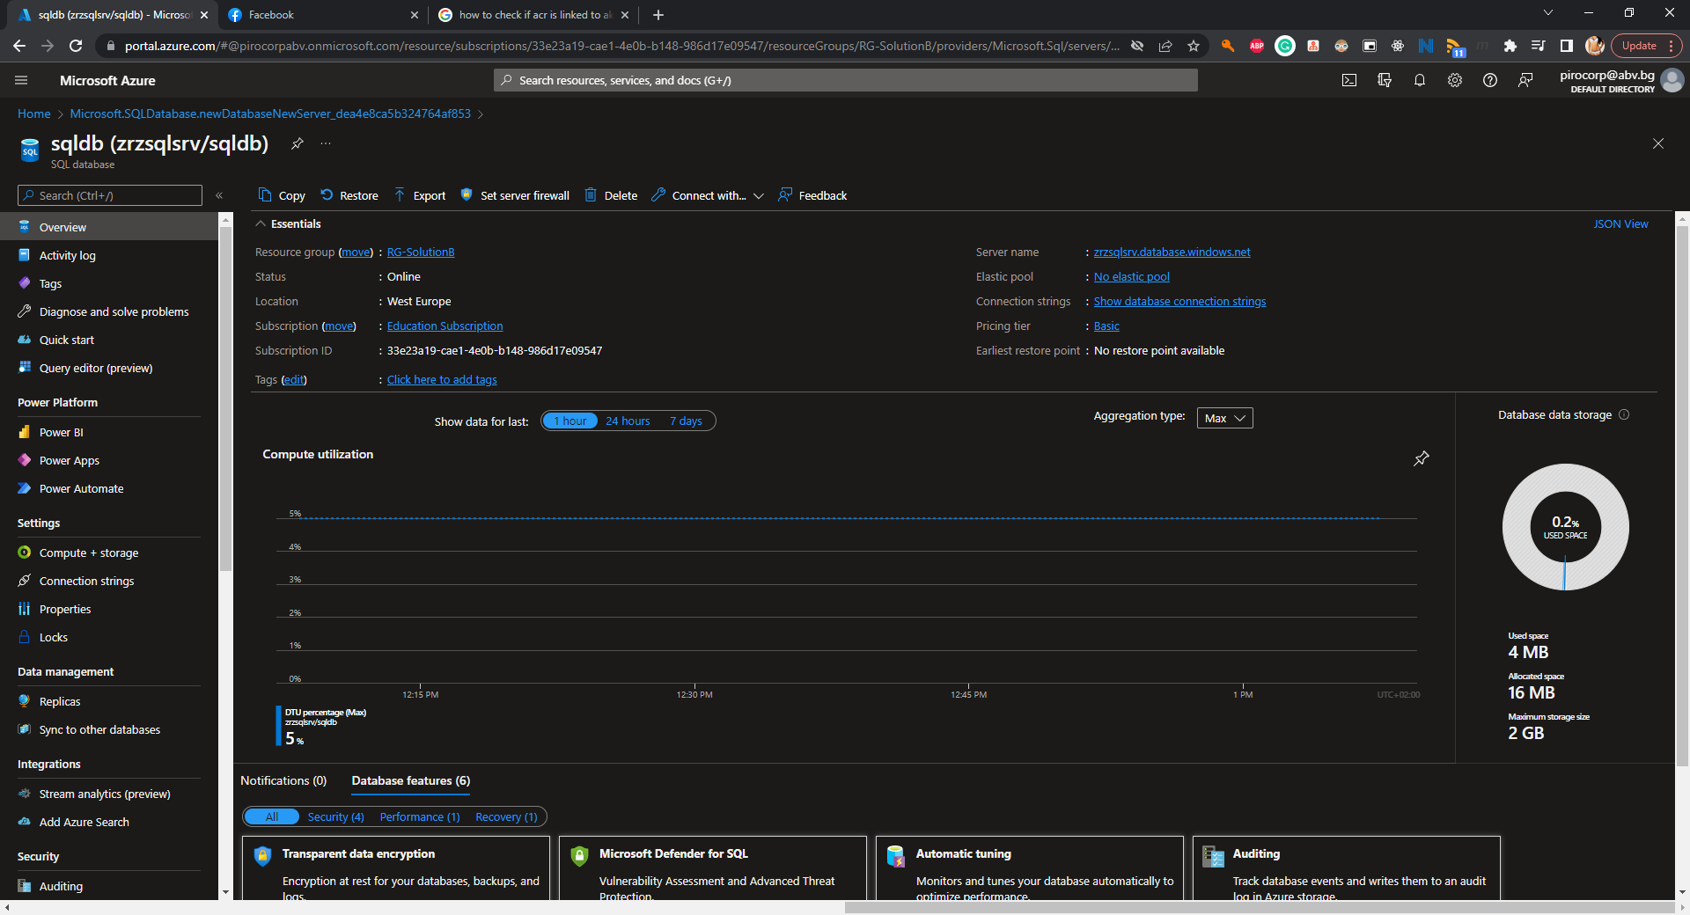

* (T302, 3 pts) Configure connectivity to the server

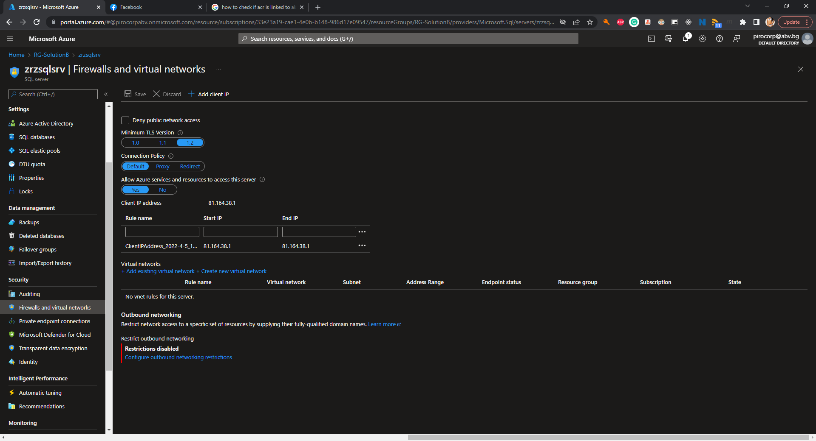

* (T303, 3 pts) Initialize the database with the help of the **create-structures.sql** file part of the supporting files set

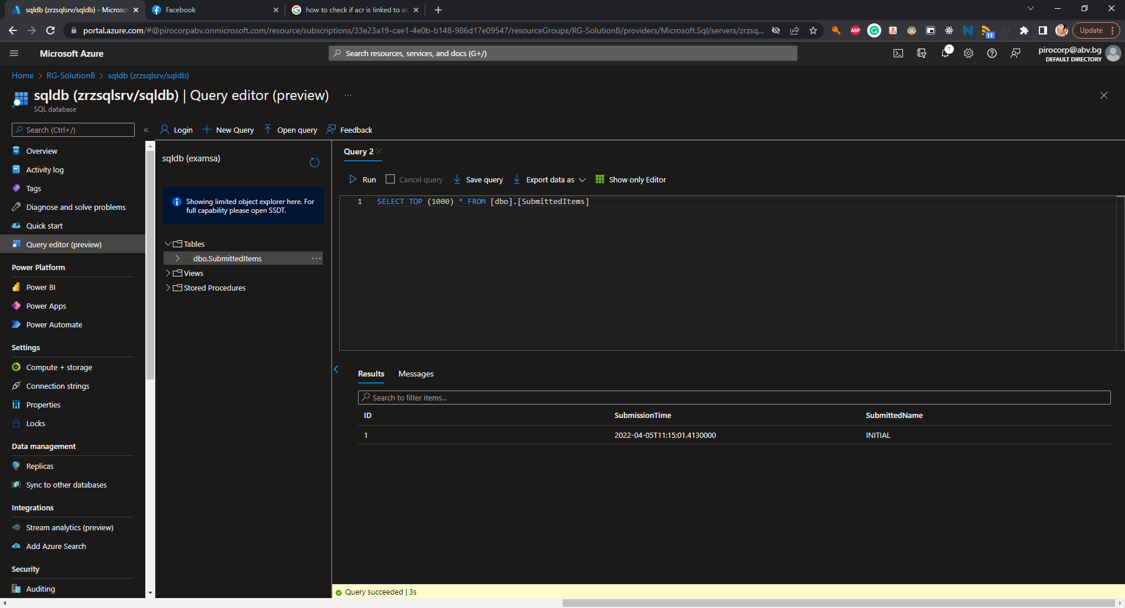

#### Web Apps and Functions - 8 tasks, 22 pts

* (T501, 3 pts) Create a PHP code-based (not container-based) web application (App Service) *

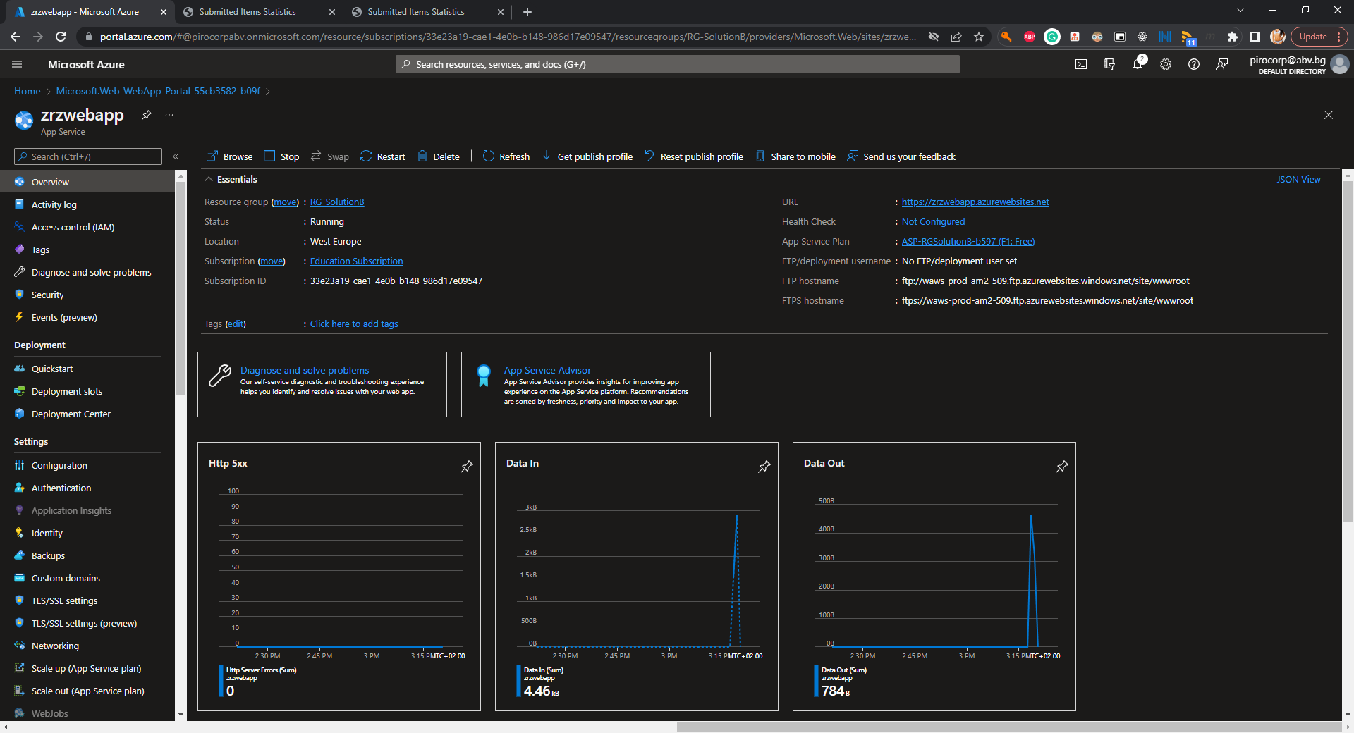

* (T502, 2 pts) Add the SQL connection string to the **index.php** file in the **webapp** folder

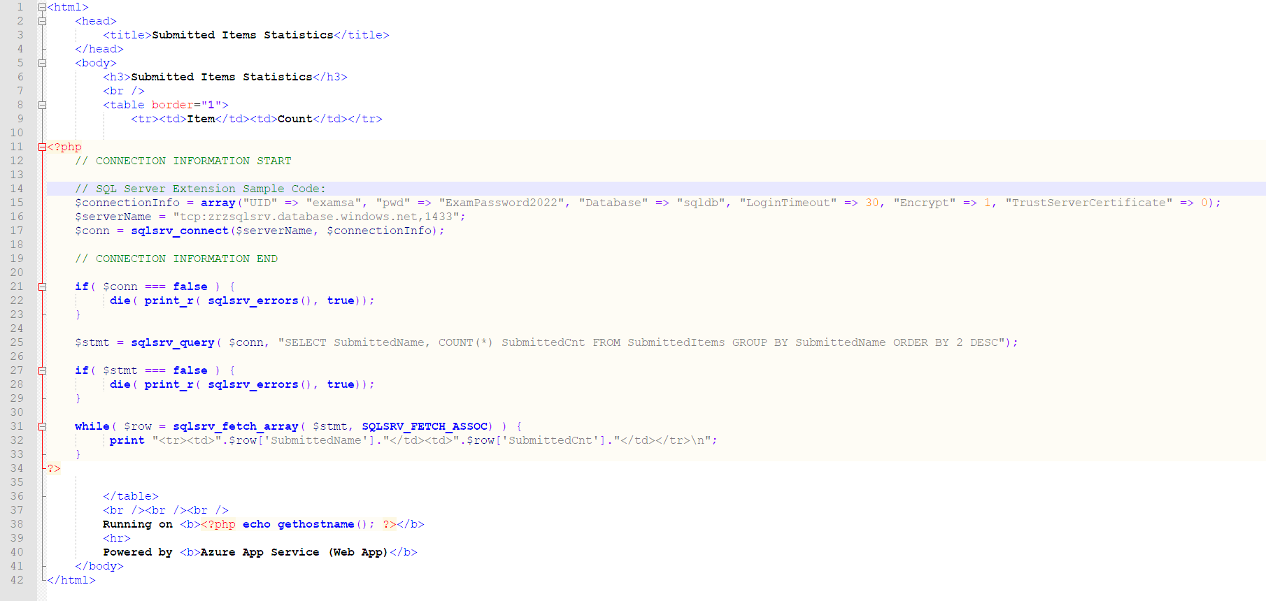

* (T503, 2 pts) Deploy the web application code to Azure

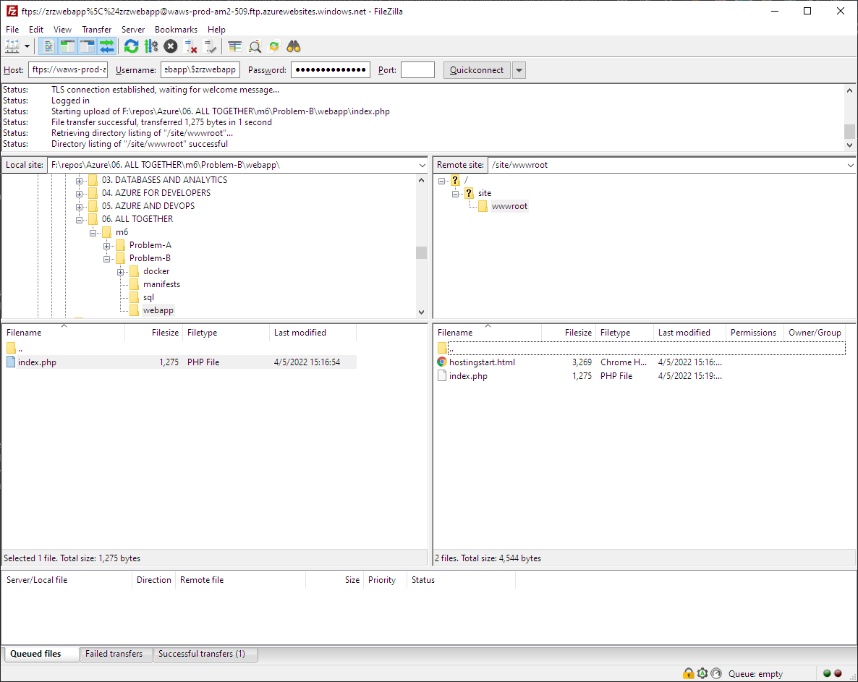

* (T504, 2 pts) Make sure that the web app is working and showing correct results

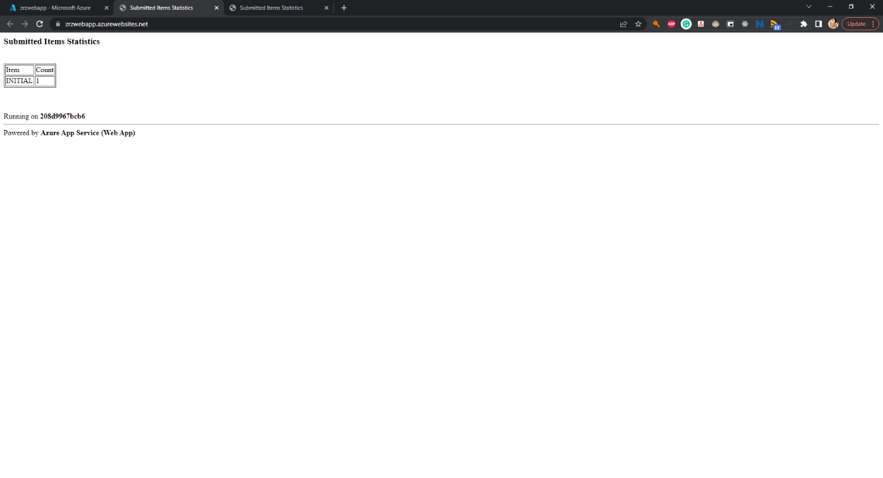

* (T505, 3 pts) Create a code-based **Function App** with **.NET Core** as runtime *

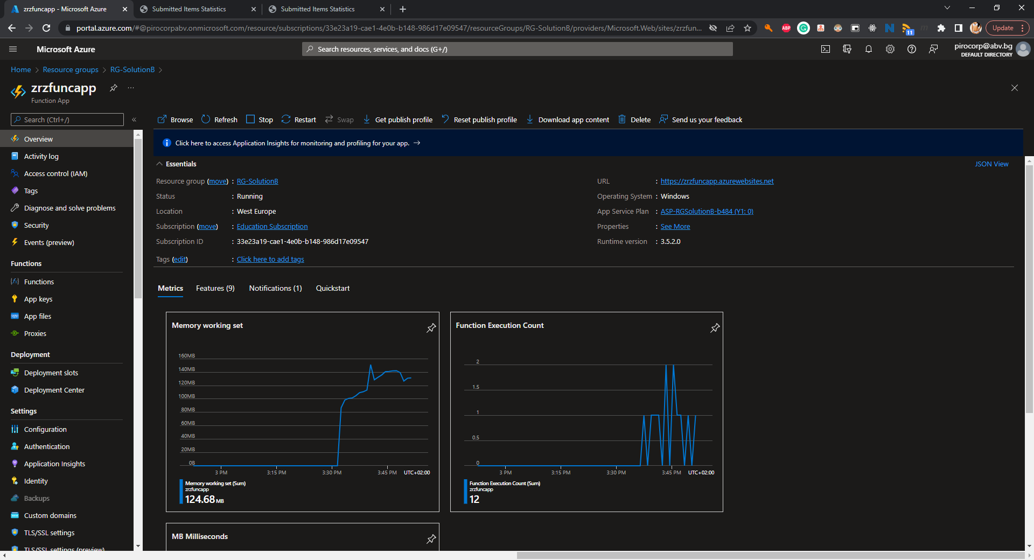

* (T506, 3 pts) Create a **Timer triggered** function. It must execute **every two minutes** and insert a row with **SubmittedName=TIMER** in the database (table **SubmittedItems**)

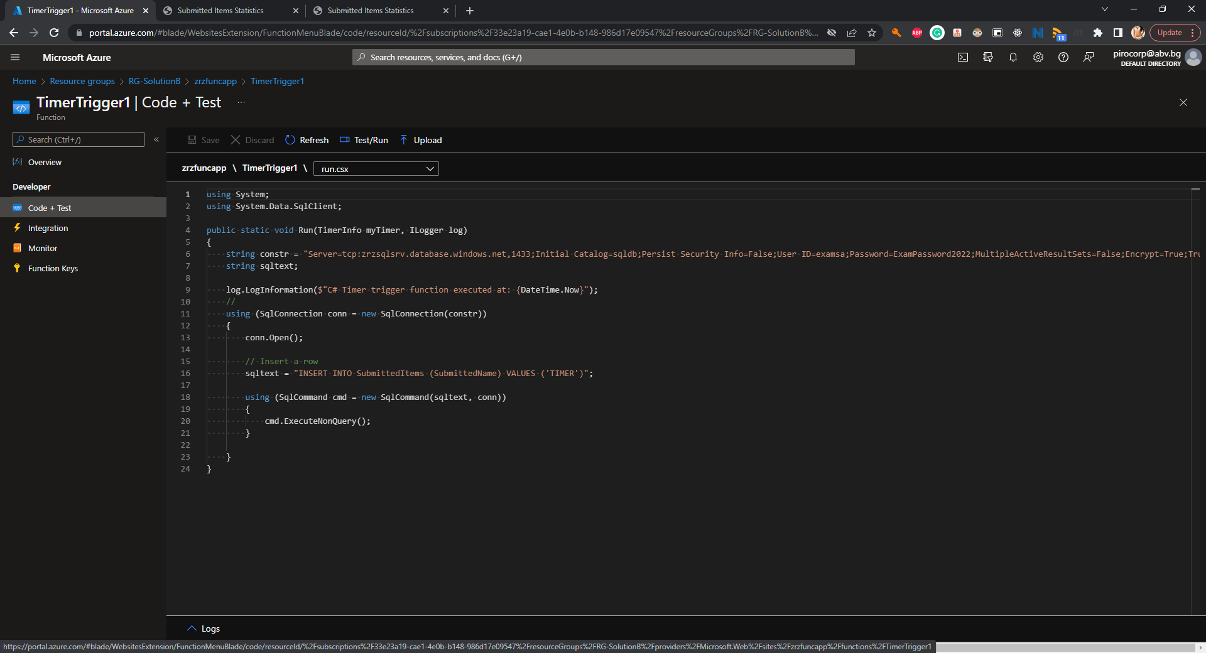

* (T507, 5 pts) Create a **HTTP triggered** function. When executed it must accept a single parameter (**name**), store the value in the database (table **SubmittedItems**), and return how many times the value has been inserted and when was the first time. The format should be **VALUE has N copies and the first one was inserted on TIME**. For example, if the function was called 5 times with the text **Exam**, and the first execution was on **17.10.2020 09:30**, then it should return **Exam has 5 copies and the first one was inserted on 17.10.2020 09:30**. Please note that the format of the time is not important and may not match the example

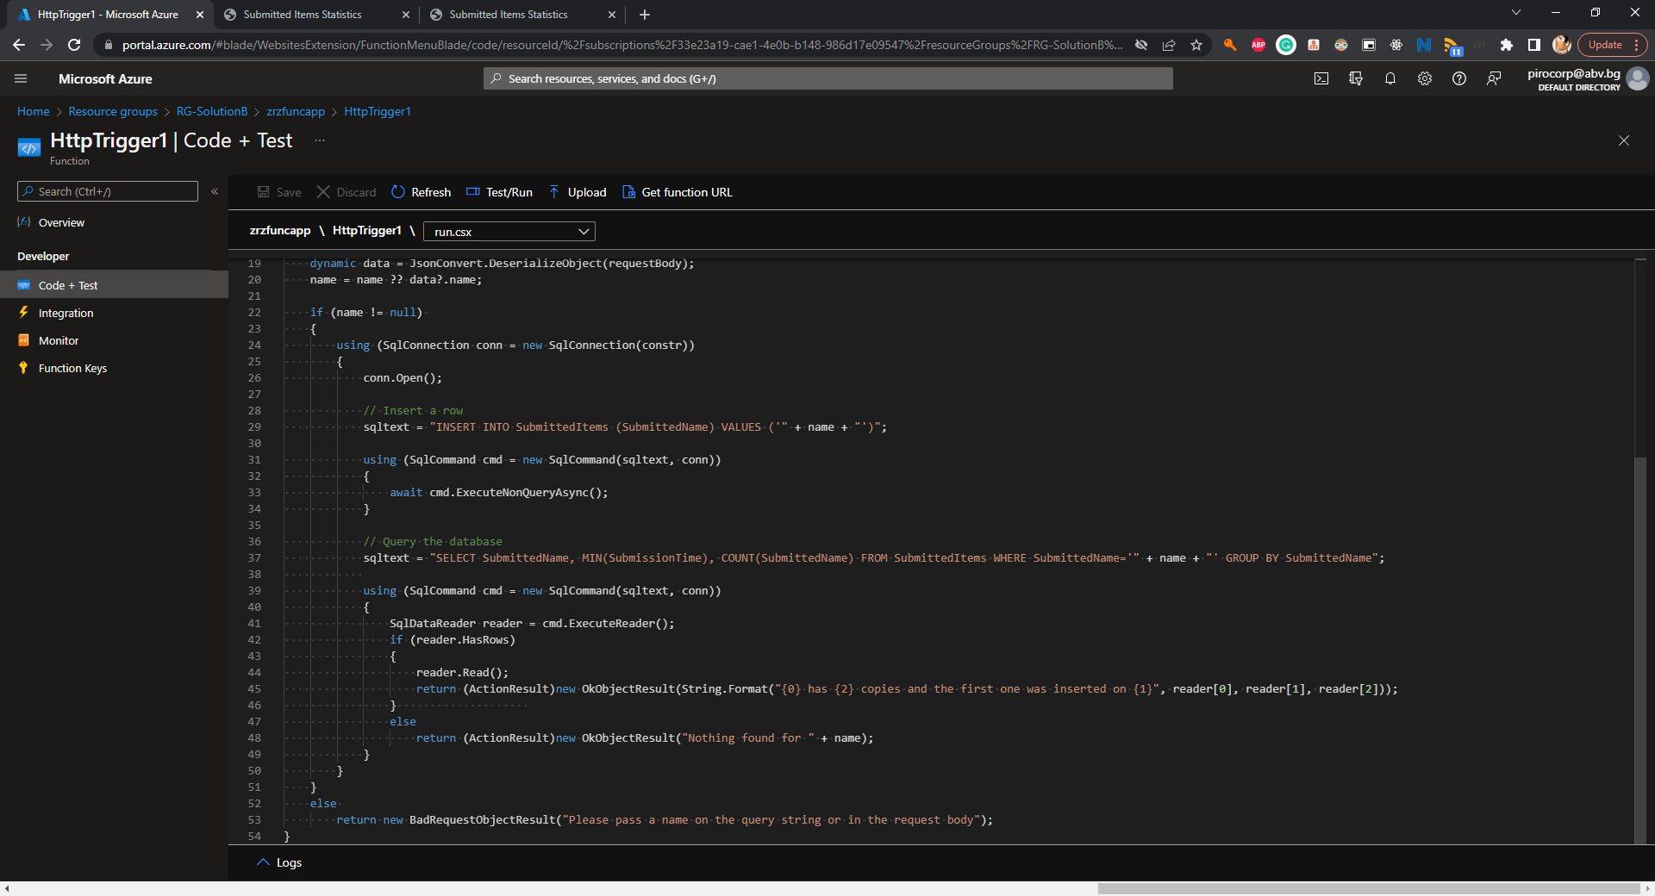

* (T508, 2 pts) Make sure that you have executed the HTTP triggered function successfully several times

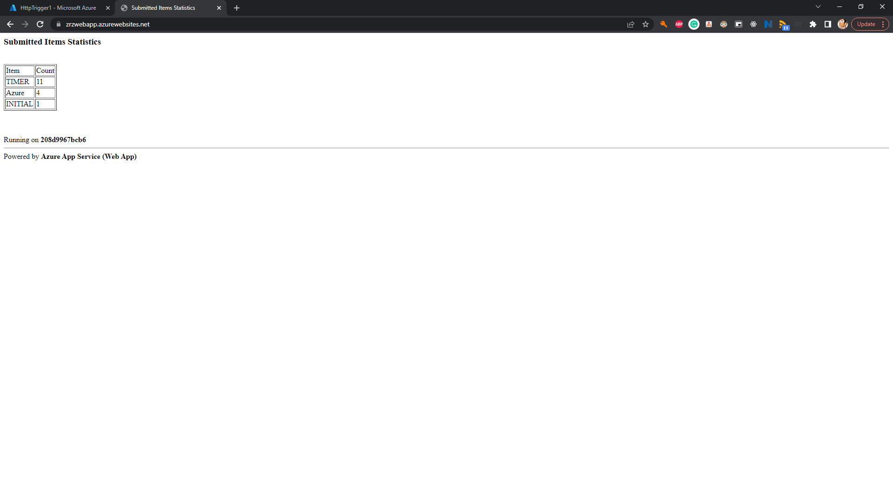

*\* Note that you may need to create an additional resource group(s)*